

Assiut University
Faculty of Medicine
ENT Department
Phoniatric unit

CURRICULUM VITAE

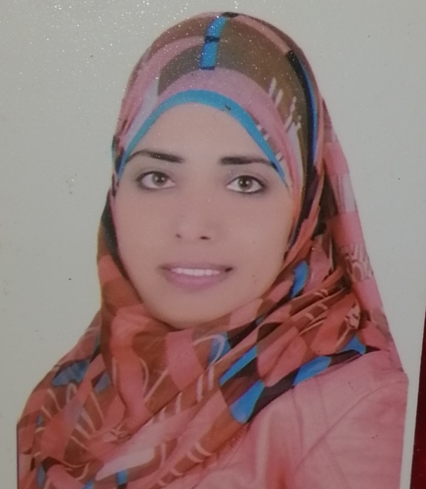

Asmaa Fathy Mohamed
Demonstrator of ENT,
Phoniatric unit
Assiut University Hospital,
Assiut, Egypt

Personal data
Name | Asmaa Fathy Mohamed Hussien
Data of birth | 24th of November 1991
Address | Egypt, Assiut university hospital, department of ENT, Phoniatrics unit
Current hospital | Department of ENT, Phoniatrics unit, Assiut University Hospital, Assiut, Egypt.
Nationality | Egyptian
Place of birth | Manflout – Assiut
Marital status | Married
Mobile NO. | +2-01014889306
E-mail | asmaafathy254@yahoo.com

Education and Research activities
University degree:
The M.B.B.CH degree in medicine and surgery -Assuit universty
Graduation Degree :
Excellent with the degree of honor
Graduation Year :
September 2015
Obligatory training year:
I had spent it as a house officer in the period between 1-3-2016 till 28-2-2017.
Resedency year:
Begin to work as a resident physician of phoniatrics from 3- 2017 till 9-2019.
Domenstratoin year:
Begin to work as a domenstrator from 9-2019 up till now.
Research activities:
Correlation between the Arabic Pediatric Voice Related Quality of Life, the Auditory Perceptual Assessment and Acoustic Analysis of Voice in Dysphonic Children (M.Sc. thesis): Eman Sayed Hassan, Reham AbdEl-Wakil Ibrahim, Asmaa Fathy Mohamed, 2020.

Soft Skills
- Interactive and fast enough to learn new technology.
- Able to work in group-under pressure- stress management -helpful and calm.
- High communications skills.
- Ability to meet deadlines successfully maintaining the quality of work.

Special Skills
- Word, Excel and Internet.
- EndNote x7.

Language
Language | Read | Write
Arabic | Mother Tongue
English | Very Good in command of spoken language | Very Good in command of written language
Computer Skills & Attributes
Operating Systems : Win 95/98/2000/XP/win7/win8
Software : Office 2003/2007xp All Applications.
Internet : Browsing, e-mail

Qualification
- Honored to get the 35th place in the graduation record of 2016.
- Graduate trainee in basic course of “Basic Surgical Skills”, 2016, Faculty of Medicine – Asyut University.
- Graduate trainee in basic course of “Cardio-Pulmonary Resuscitation”, 2016, Faculty of Medicine – Asyut University.
- Graduate trainee in basic course of “Ethical, Law and Administrative Considerations in Medical Practice”, 2016, Faculty of Medicine – Asyut University.
- Graduate trainee in basic course of “Infection Control”, 2016, Faculty of Medicine – Asyut University.
- Had attended the”Pre-employment orientation program” at March 2017.
- Participation in the weekly seminar of our phoniatric unit.
- Had attended successfully workshop in “Infection Control”, Faculty of Medicine, at quality assurance unit – Asyut University at 2018.
- Had attended successfully workshop in “Evidence Based medicine”, Faculty of Medicine, quality assurance unit – Asyut University at 2018.
- Had attended successfully workshop in “writing medical reports”, Faculty of Medicine, quality assurance unit – Asyut University at 2018.
- Had attended conference about “world voice day celebration”, at Assiut University - April 2017.
- Had successfully completed the cognitive and skills evaluations in accordance with the curriculum of the American Heart Association Basic Life Support (CPR and AED) program at 17 December 2019.
- Had attended and actively participated in 8th Assiut conference of Otolaryngology– Assiut at 4- 6 December 2017.
- Had attended and actively participated in 8th National congress of the Egyptian Society of Phoniatrics and Logopedics – Luxor at 13- 15 March 2018.
- Had attended for instruction course on phonosurgery -8th National congress of the Egyptian Society of Phoniatrics and Logopedics – Luxor at 13- 14 March 2018.
- Became a member of the Egyptian Society of Phoniatrics and Logopedics at March 2018.

